**Problem 1:**

1. A protoplanet is a collection of whirlpools/eddies of gas and dust, that shrinks into a condensed mass. This mass can later form planets and moons with a differentiated interior [1]. Vesta is considered a protoplanet due to its differentiated inner structure, which consists of a rocky mantle and iron-nickel core [2]. Vesta is the 2nd largest asteroid in the main asteroid belt [3]. Vesta is also one of the fastest rotators of the large asteroids with a period of 5.342 hours [4]. Vesta was discovered in 1807 by Heinrich Wilhelm Olbers and was named after the goddess of the hearth and household in Roman mythology [3]. The orbit of Vesta was computed by Carl Gauss, who was given the honor of naming the asteroid [3].
2. Vesta’s orbit is not in the same plane as Earth’s orbit. The angular difference between Earth and Vesta’s orbit appears to be approximately 10 degrees. Vesta has a magnitude of 7.97, therefore Vesta is considered visible as its magnitude is less than 20.
3. The LOS between Earth and Vesta is unobstructed on 9/27/07, as shown in the screenshot below. This coupled with the Vesta’s magnitude of 7.58 on 9/27/07 ensured Vesta was viewable.

1. On 7/15/11, the LOS between Earth and Vesta is unobstructed by the sun or any planets, as shown below, so there is no alignment problem.

On 9/4/12, the LOS between Earth and Vesta is unobstructed by the sun or any planets, as shown below, so there is again no alignment problem.

The sun, Earth, and Vesta appear to all be aligned on 12/8/12, as shown below.

1. The distance to Earth from Vesta is tabulated below for the above set of dates, and 8/10/34.

|  |  |
| --- | --- |
| **Date** | **Distance to Earth [Million Km]** |
| 7/15/11 | 188.9 |
| 9/4/12 | 368.2 |
| 12/8/12 | 237.7 |
| 8/10/34 | 463.5 |

On 8/10/34, there will be a LOS between Earth and Vesta. On this date, Vesta will be further from Earth than when Dawn departed Vesta (9/4/12).

1. The orbital inclination of Vesta is ~7.14 degrees. Relatively close to the initial estimate in b). Inclination can help improve LOS if objects are obstructing the LOS when aligned, as the inclined orbit may be elevated over the obstructing object. The orbital period of Vesta is ~3.63 years, or 1326.8 days. The number of days between Dawn departing Vesta (9/4/12) and 8/10/34 is 8010 days. Therefore, in this time frame, Vesta will have completed 6 orbital periods.

**References:**

1. S.K. Haldar, Chapter 4 - Basic petrology, Introduction to Mineralogy and Petrology (Second Edition), <https://www.sciencedirect.com/science/article/pii/B9780128205853000041>
2. A look into Vesta's interior, <https://www.mpg.de/877913/Vesta_asteroid>
3. *NASA Solar System Exploration* <https://science.nasa.gov/solar-system/asteroids/4-vesta/>
4. Russell, C. T. "Exploring the smallest terrestrial planet: Dawn at Vesta" <https://meetingorganizer.copernicus.org/EPSC-DPS2011/EPSC-DPS2011-97-3.pdf>

**Problem 2**:

1. Pluto Orbit: Appears to be in orbit around the sun and is not a satellite/moon of another planet. Criteria (i) and (iv) are satisfied.

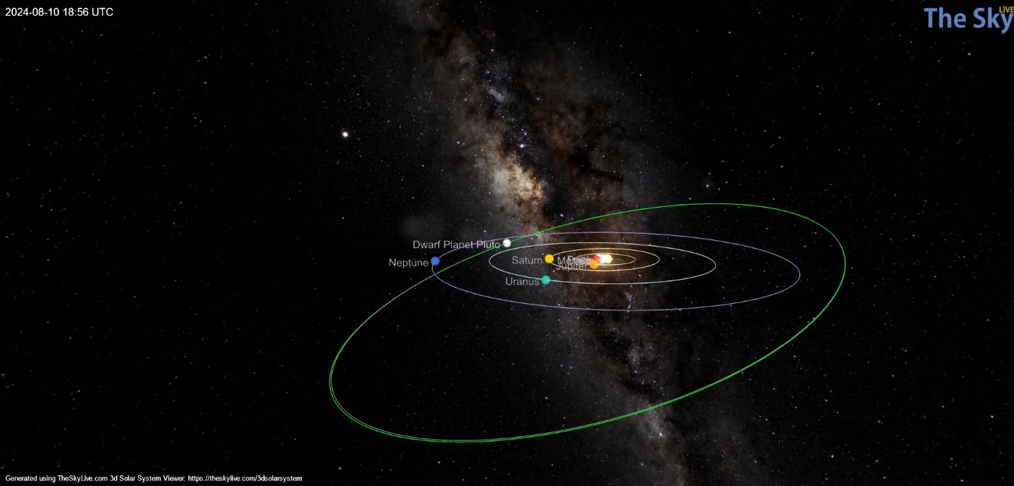

Eris Orbit: Appears to be in orbit around the sun and is not a satellite/moon of another planet. Criteria (i) and (iv) are satisfied.

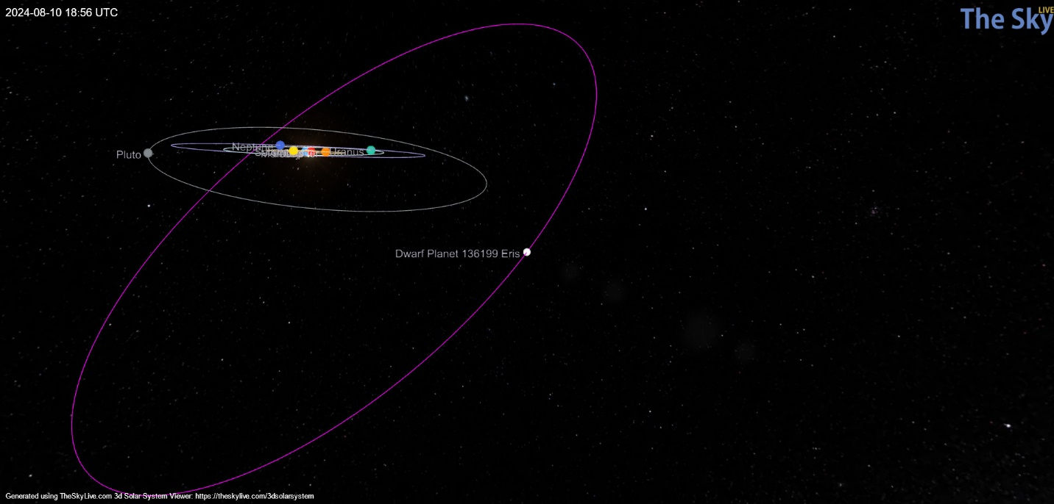

Makemake Orbit: Appears to be in orbit around the sun and is not a satellite/moon of another planet. Criteria (i) and (iv) are satisfied.

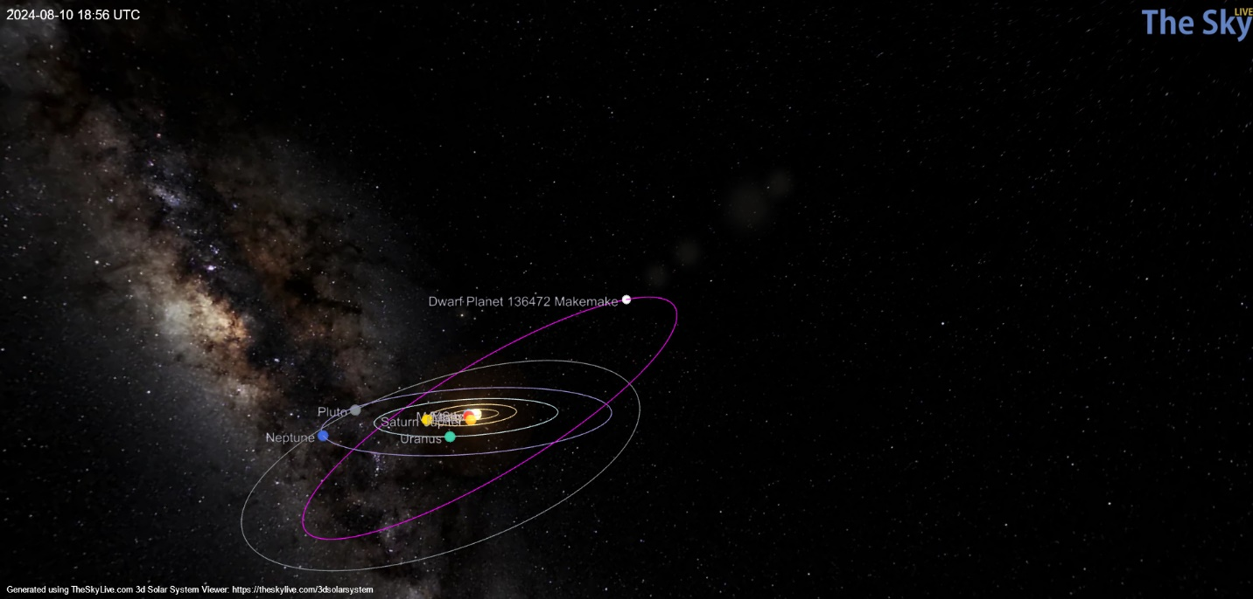

Haumea Orbit: Appears to be in orbit around the sun and is not a satellite/moon of another planet. Criteria (i) and (iv) are satisfied.

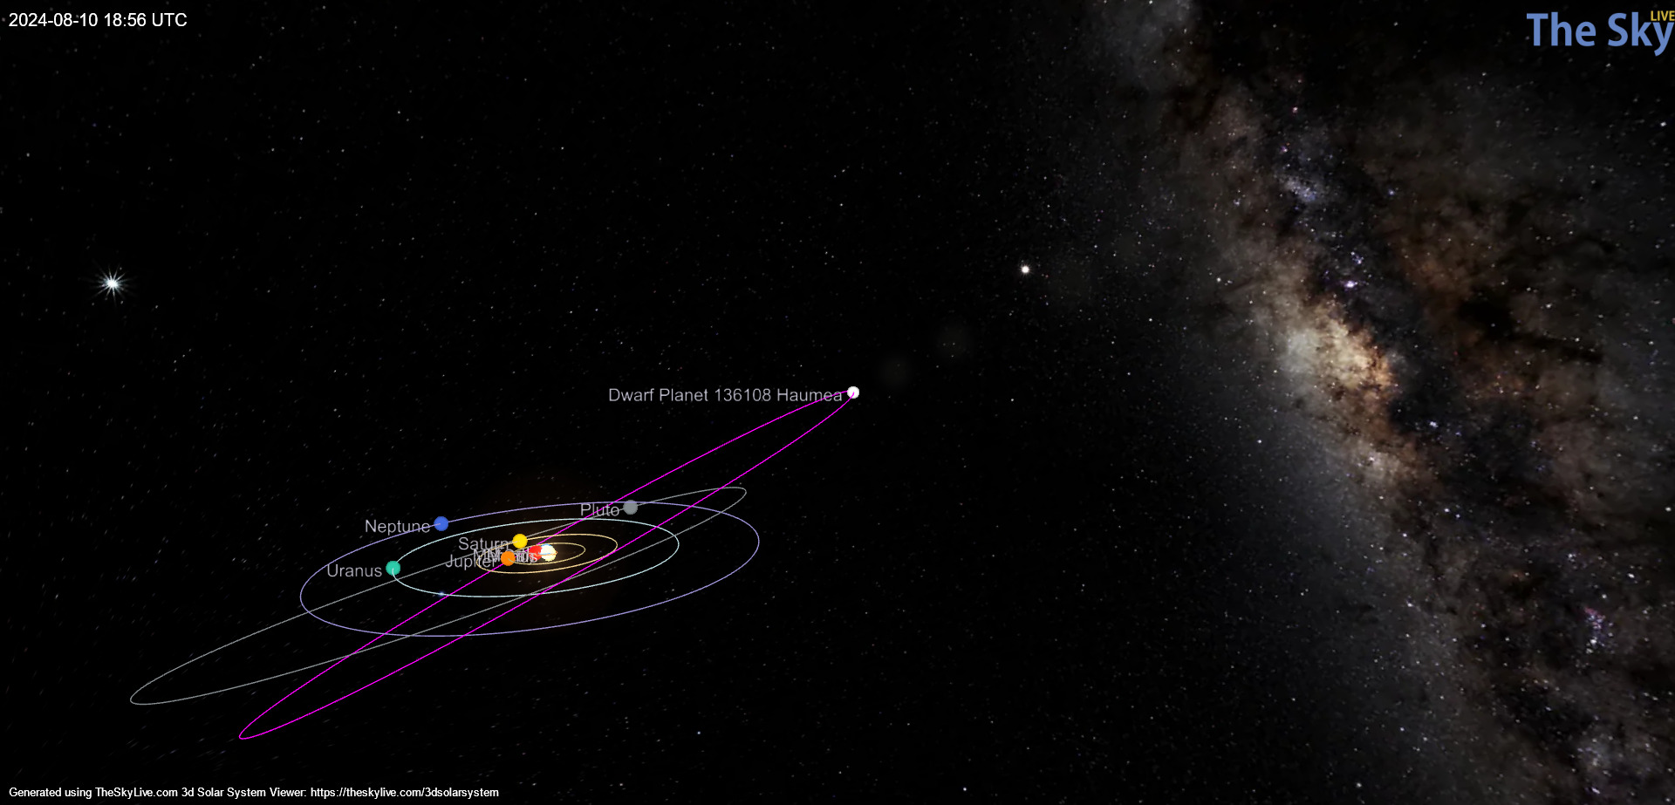

Ceres Orbit: Appears to be in orbit around the sun and is not a satellite/moon of another planet. Criteria (i) and (iv) are satisfied.

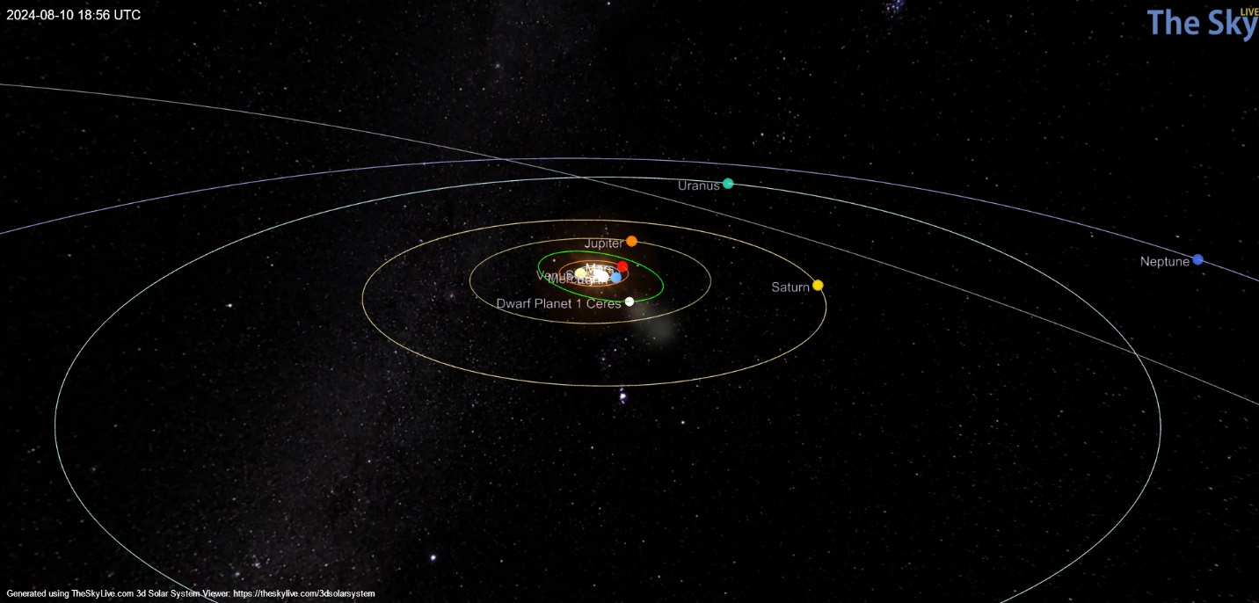

Sedna Orbit: Appears to be in orbit around the sun but is very far away in comparison to the other dwarfs. Is not a satellite/moon of another planet. Criteria (i) and (iv) are satisfied.

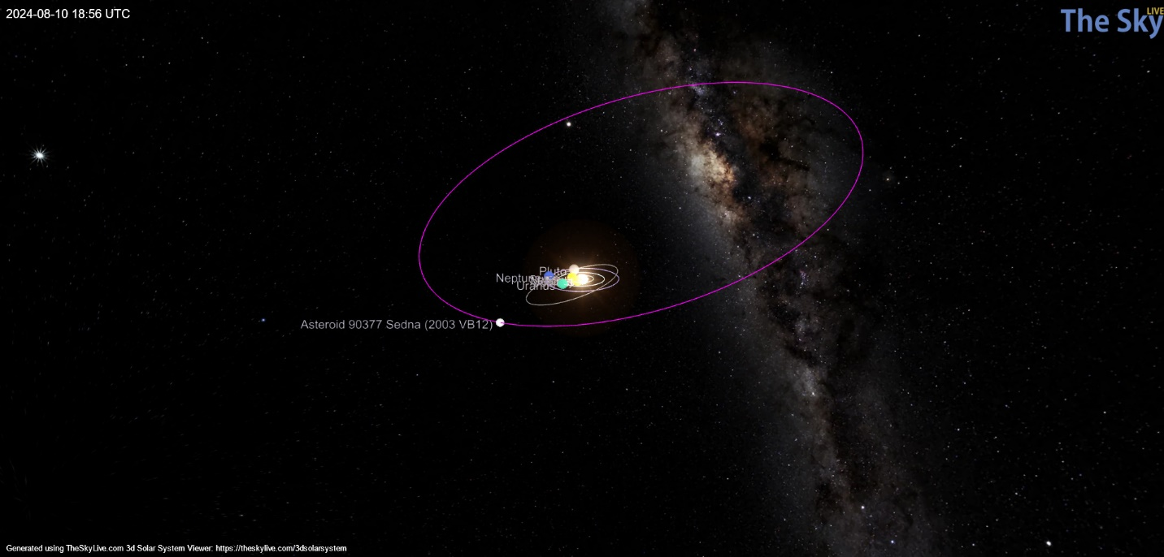

Gonggong Orbit: Listed as provisional designation 2007 OR10, appears to be in orbit around the sun and is not a satellite/moon of another planet. Criteria (i) and (iv) are satisfied.

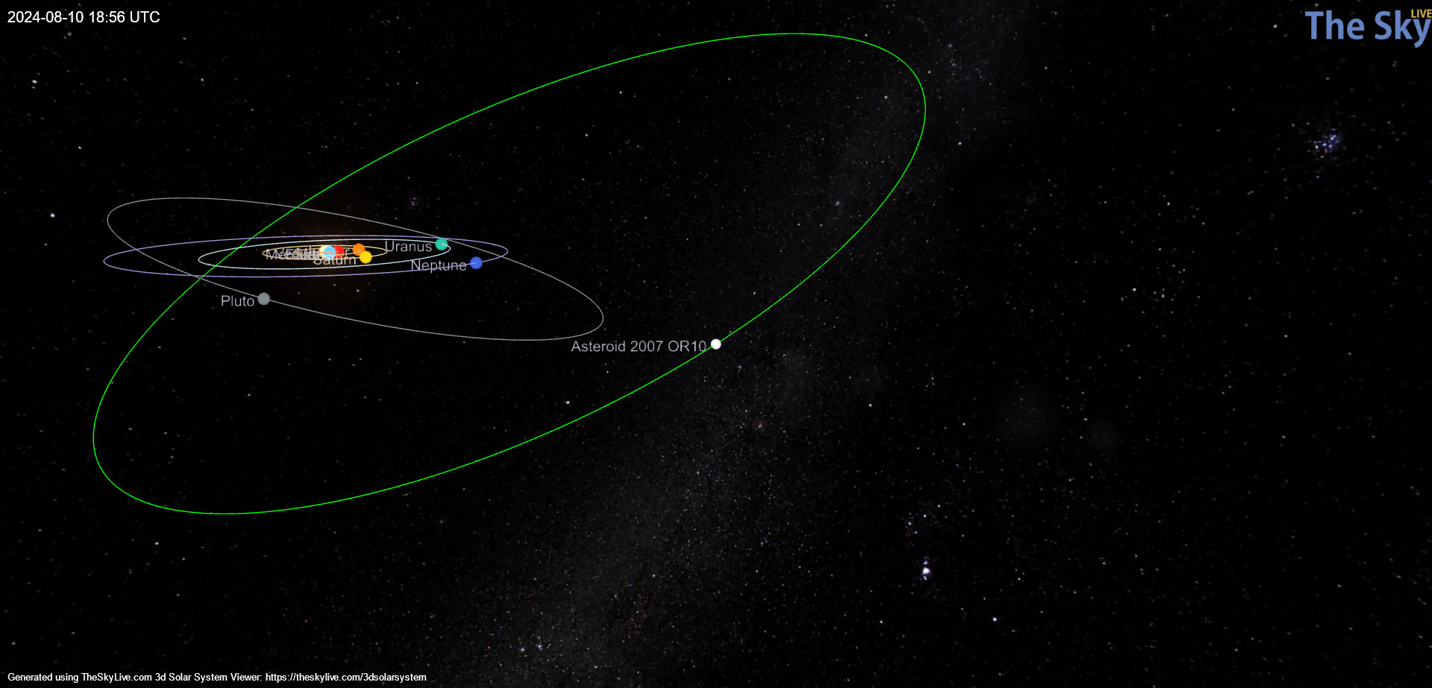

**Quaoar and Orcus are not displayed as objects in the tool used above.**

b)

|  |  |  |  |  |  |  |  |  |  |
| --- | --- | --- | --- | --- | --- | --- | --- | --- | --- |
| **Dwarf Planet** | **Pluto** | **Eris** | **Makemake** | **Haumea** | **Ceres** | **Orcus** | **Sedna** | **Gonggong** | **Quaoar** |
| **Distance from Earth (8/10/24)** | 34.1 AU | 95.28 AU | 53.23 AU | 50.23 AU | 2.06 AU | Unknown | 83.60 AU | 88.43 AU | Unknown |
| **Period of Orbit** | 249.09  Years | 562.55  Years | 304.54  Years | 281.07  Years | 4.60  Years | 245.79  Years | 12,281.48  Years | 551.9  Years | 283.88  Years |
| **Semi-Major Axis** | 39.59 AU | 68.14 AU | 45.26 AU | 42.91 AU | 2.77 AU | 39.24 AU | 532.3 AU | 67.28 AU | 43.19 AU |
| **Inclination** | 17.15  degrees | 43.76  degrees | 29.02  degrees | 28.21  degrees | 10.57  degrees | 20.56  degrees | 11.93  degrees | 30.64  degrees | 7.99  degrees |

On 8/10/24, Eris, Makemake, Haumea, and Gonggong are further from Earth than they are on the semi-major axis on their orbit around the sun. Ceres is the planet closest to Earth on 8/10/24. Ceres crosses into the ecliptic plane on 8/10/2042, so we need to wait 18 years.

c)

*Orcus*: Discovered in 2004. Has 1 moon named Vanith. The size of Orcus and Vanith cannot be determined separately, rather as one body that is ~940 km in diameter. It is estimated Orcus would be 860 kilometers across, and Vanth 380 kilometers. Named after Roman god of death.

**Ref**:

Orcus and Vanth - <https://www.planetary.org/articles/2873>

NASA JPL Small Body Database Lookup - [https://ssd.jpl.nasa.gov/tools/sbdb_lookup.html#/?sstr=orcus&view=OSPD](https://ssd.jpl.nasa.gov/tools/sbdb_lookup.html%23/?sstr=orcus&view=OSPD)

*Sedna:* Discovered in 2003. It is ~1800 km in diameter. There is evidence of a moon, but no moon is currently visible. The planet is named after the Inuit sea goddess Sedna.

**Ref**: <https://web.gps.caltech.edu/~mbrown/sedna/>

*Gonggong*: Discovered in 2007. Has a single moon called Gonggong I Xiangliu (unknown size). Named after the Chinese water god. Gongong is ~1457 km in diameter.

**Ref:** [https://www.spacereference.org/asteroid/225088-gonggong-2007-or10](https://www.spacereference.org/asteroid/225088-gonggong-2007-or10%20)

NASA JPL Small Body Database Lookup - [https://ssd.jpl.nasa.gov/tools/sbdb_lookup.html#/?sstr=225088](https://ssd.jpl.nasa.gov/tools/sbdb_lookup.html%23/?sstr=225088)

*Quaoar:* Discovered in 2002. Approximately 1100 km in diameter. Has a single moon named Quaoar I Weywot. Named after the force of creation to the indigenous people of the Los Angeles basin.

**Ref**: NASA JPL Small Body Database Lookup - [https://ssd.jpl.nasa.gov/tools/sbdb_lookup.html#/?sstr=Quaoar&view=OSPDA](https://ssd.jpl.nasa.gov/tools/sbdb_lookup.html%23/?sstr=Quaoar&view=OSPDA)

NASA, Quaoar **-** <https://science.nasa.gov/resource/quaoar/>